Statistics Lecture 8.4: Hypothesis Testing for Population Mean. Population Std Dev is Known

* For claims involving the population mean when the standard deviation is known

Requirements:
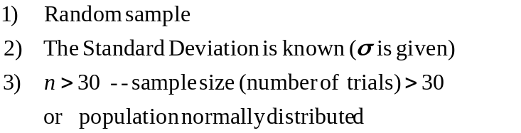

Test Statistic
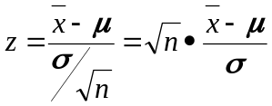

Example
M&M’s: you sample 465 M&Ms. The sample had a average of 0.8635 grams. The population standard deviation is 0.0565 grams.

Test the claim that the mean weight is greater than 0.8535 grams. With a confidence level of 99% giving a 0.01 significance level.

Step 1 Identify claim and opposite
Claim: 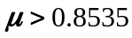
Opposite: 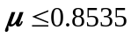

Step 2 Set up Null and alternative Hypothesis.
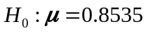
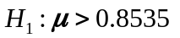

Step 3 Identify Significance Level
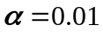 One tail

Step 4 Calculate the Test Statistic
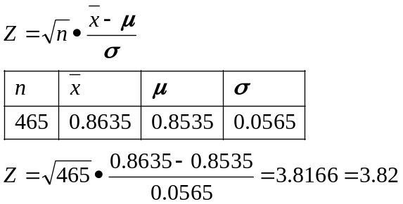

Step 5 Graph

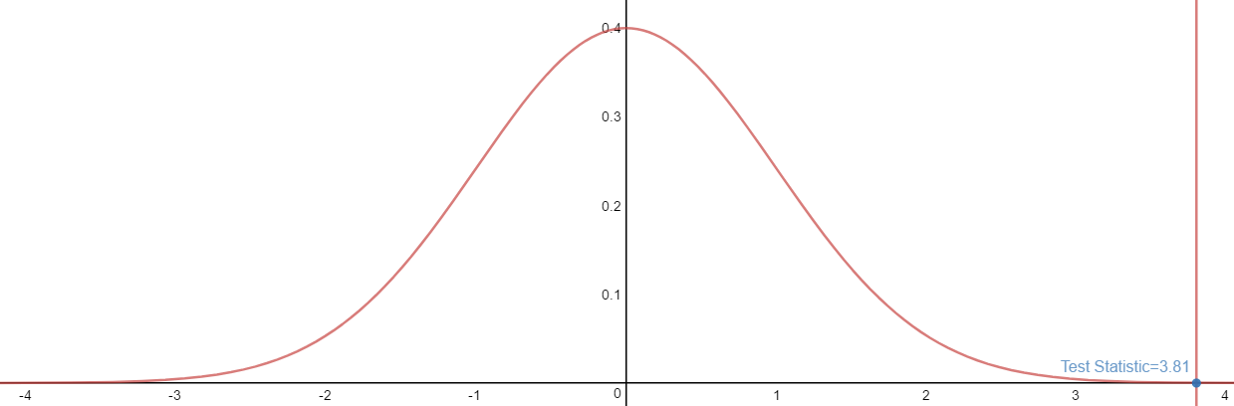
Test statistic = 3.82 (Right tail test)

P-value is the area in the tail(s)
Area= 0.99993
P-value=1-0.99993=0.00007
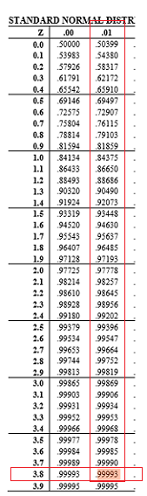

Step 6 Make a decision
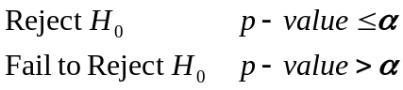
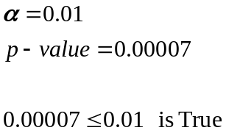
Reject 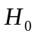 therefore 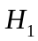 Is true

Step 7 Interpret
Reject There is enough evidence to support the claim that the mean weight is greater than 0.8535 grams

Step 5 Graph Traditional

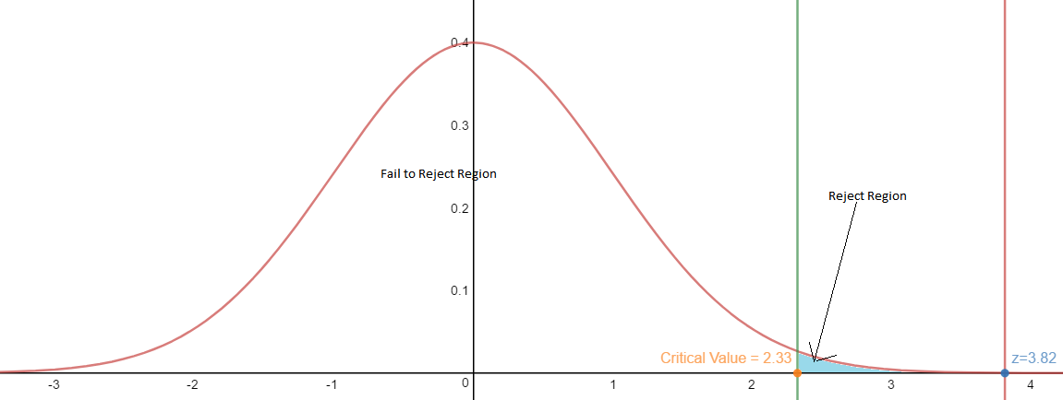

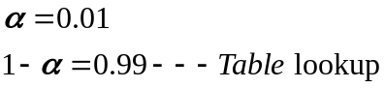 One tail

Critical Value =2.33
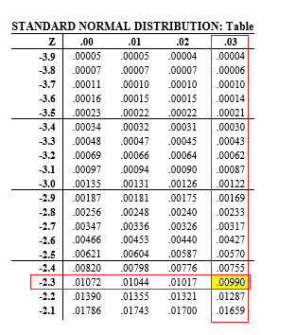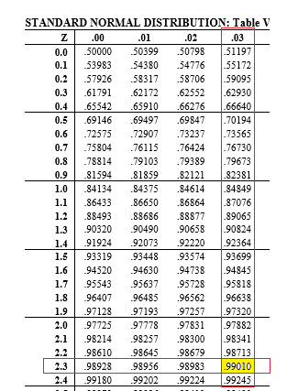

Step 4 Calculate the Test Statistic
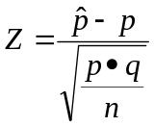
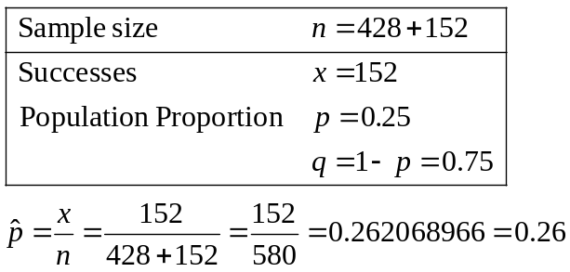

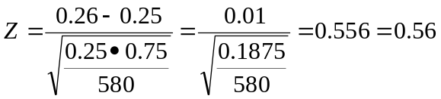
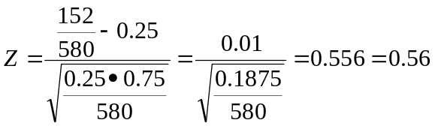

Step 5 graph
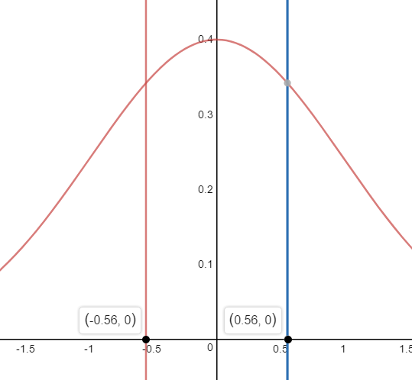
P-value is the area in the tail(s)
Area= 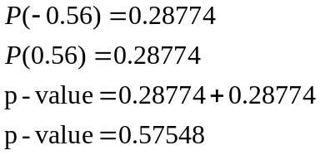

Step 6 Make a decision
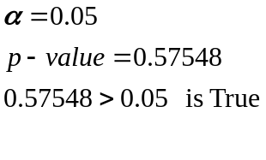
Fail to Reject therefore is unknown

Step 7 Interpret
Fail to Reject There is not enough evidence to support the claim that the proportion of yellow pods is equal to 1/4.
Step 5 graph (Tradition Method

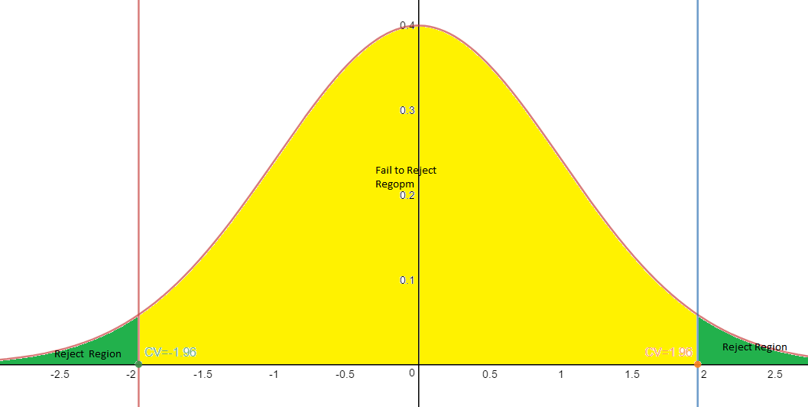
P-value is the area in the tail(s)
Area= 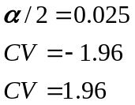

Step 6 Make a decision
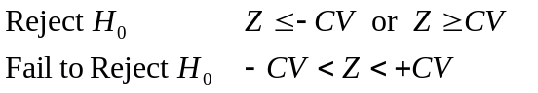
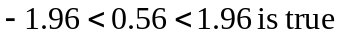
Fail to Reject therefore is unknown

Step 7 Interpret
Fail to Reject There is not enough evidence to support the claim that the proportion of yellow pods is equal to 1/4.

